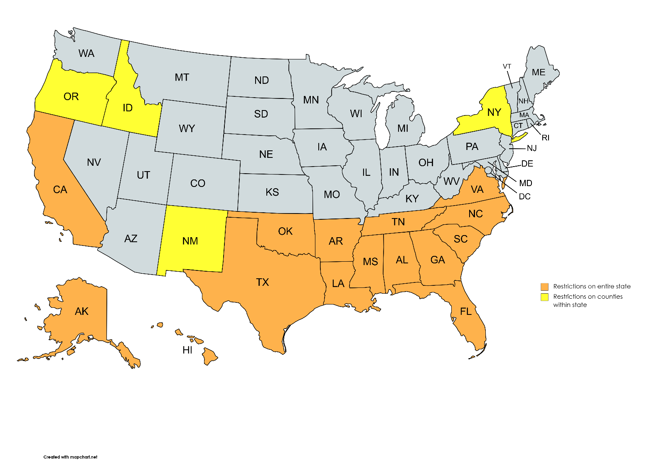
Map of Regulated States

Prohibited Areas
Areas from where soil should neither be packaged nor shipped. Soil received from these counties will be treated as quarantined and destroyed without processing.

Idaho: Bingham, Bonneville

California: Contra Costa, Los Angeles, Riverside, Sacramento, San Bernardino, Santa Clara, Ventura

Canada: Alberta: A farm unit and associated land located near the municipality of Fort Saskatchewan; and a farm unit and associated land located near the municipality of Spruce Grove British Colombia: Central Saanich on Vancouver Island
Newfoundland and Labrador: The entire Island of Newfoundland
Quebec: The municipality of Saint- Amble

Regulated States and Counties

Areas from where soil will be handled within the Cornell Soil Health Laboratory according to Quarantine Standard Operating Procedures.

Note: We accept soils from regulated areas throughout the United States. As with all samples, please be sure to double bag and use packing material to minimize sample movement during shipping.

Entire State Regulated:
- Alabama
- Alaska
- Arkansas
- California
- Georgia
- Hawaii
- Florida
- Louisiana
- Mississippi
- North Carolina
- Oklahoma
- South Carolina
- Tennessee
- Texas
- Virginia

States with regulated soils in some counties:
- New Mexico: Dona Ana
- Oregon: Curry
- New York: Bronx, Cayuga, Erie, Livingston, Monroe, Nassau, Niagara, New York, Ontario, Orleans, Kings, Queens, Richmond, Seneca, Steuben, Suffolk, Wayne

Note: The Cornell Soil Health Laboratory reserves the right to have higher levels of restrictions on the transport and analysis of soil than that of USDA-APHIS

